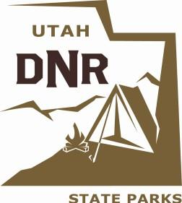

Palisade State park 9th Annual
Fishing Tournament.
May 14th, 2022
Awards are as follows: $300 value in prize or gift cards for 1st place, $200 value in prize or gift cards for 2nd place, $100 value in prizes or gift cards for 3rd place. Door prizes will be given according to a number of sponsors. (Prize amounts may change depending on sponsors and donations)

Early sign ups can be done by calling Palisade State Park at 435-835-6676 Mon-Fri 9 am to 4 pm.

Sign up and check in to be done from 6:30 am to 7:00 am at Pioneer Group site. Fishing will take place from 7:00 am until 2:00 pm from shores and by boats (Electric motors only!) You may fish anywhere around Palisade Reservoir.

Weigh-in is from 2:00 pm to 2:30 pm. Awards and prizes from 2:30 pm to 3:00 pm
Any decontamination that needs to be done concerning Quagga will need to be taken to Yuba to be decontaminated prior to launching.

All COVID-19 Safety Precautions will be followed according to CDC guidelines.
Thanks for being a part of our event!!!!

