INSTRUCTIONS FOR THE UTAH DIVISION OF PARKS AND RECREATION

OFF-HIGHWAY VEHICLE PROGRAM

ACCESS AND EDUCATION GRANT

ANNUAL APPLICATION

ELIGIBLE APPLICANTS
Funding for this application was made available through Utah Code Title 41, Chapter 22, Section 19.5.
Applications to the Access and Education Grant may be submitted by any charitable organization that:
(a) qualifies as being tax exempt under Section 501(c)(3) of the Internal Revenue Code;
(b) has at least one full-time employee; and
(c) has as a primary part of its mission to:
(i) protect access to public lands by motor vehicle operators; and
(ii) educate the public about appropriate off-highway vehicle use.

ELIGIBLE PROJECTS
The Access and Education Grant can fund projects that intend to
- Protect Access to public lands by motor vehicle and off-highway vehicle operators. Funds may also be used to cover litigation expenses incurred in protecting access to public lands by motor vehicle and off-highway vehicle operators.

- Educate the public about appropriate off-highway vehicle use.

FUNDING CAP
For this application, there is a total funding amount of $17,500.00 available.

MATCHING FUNDS
No matching funds are required.

THE PROCESS
Submitted applications will be reviewed by the Utah Division of Parks and Recreation Off-Highway Vehicle (OHV) Program staff. The anticipated review should take place during the month of May. Once Program staff has reviewed the applications, their recommendations will be vetted through the Board of Utah State Parks and Recreation for final review before awarding applicants. Award notification is to be expected two- to four weeks after the deadline.

Applicants may be contacted to clarify the details and merits of their proposal.

If project managers have questions please contact Rachel Toker, OHV Program Grant Administrator, at (385) 303-1519 or racheltoker@utah.gov

DEADLINE
Applications must be in the Utah Division of Parks and Recreation Salt Lake Office on or before 5 PM, Saturday, May 1, 2021. Late applications will not be accepted.

Please submit applications electronically to: racheltoker@utah.gov
or by mail: RACHEL TOKER

UTAH DIVISION OF PARKS AND RECREATION

1594 West North Temple Suite 116

PO Box 146001

Salt Lake City UT 84114-6001

APPLICATION INSTRUCTIONS
Once completed and signed, the application is preferred to be submitted electronically. Otherwise, it may be mailed (U.S. Postal Service, FedEx, UPS, etc.), hand-delivered to the address above.

All items listed below under “Application Checklist” must be included in order to be considered for grant funding, unless if applicable.

If the application is submitted electronically, all documents should be converted to a single PDF file that has the applicant's digital signature.

APPLICATION CHECKLIST
□ COMPLETED AND SIGNED APPLICATION
□ MAP of the project for which funding is being requested, if applicable
□ DETAILED PROJECT BUDGET
□ PHOTOGRAPHS of proposed project, if applicable
□ NONPROFIT:
Include*:
□ W-9
□ Proof that nonprofit organization has at least one full-time employee (with benefits)
□ Nonprofit 501(c)(3) status
□ Most recent bylaws
□ Approved board meeting minutes for which funding is supported
□ Supporting financial documentation

* Include these documents even if your organization has received state funds in past.

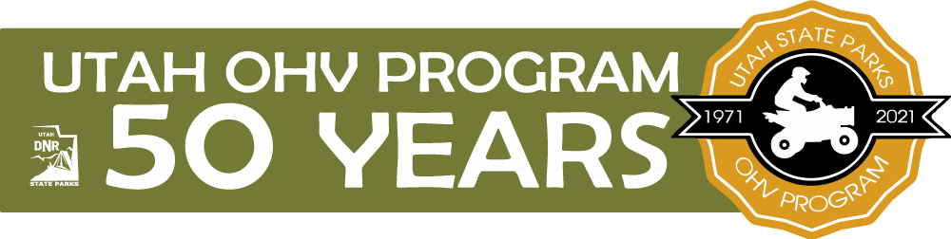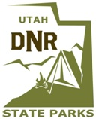
UTAH DIVISION OF PARKS AND RECREATION
OFF-HIGHWAY VEHICLE

ACCESS AND EDUCATION GRANT

FY21 APPLICATION

Section A: Project Overview

A1. Project Title: ____________________________________________________________

A2. Project Sponsor: _________________________________________________________

A3. Location (nearest town): ___________________________________________________

A4. County or Counties: _______________________________________________________

A5. Project Manager: _________________________________________________________

A6. Address: _______________________________________________________________

A7. Telephone: ______________________ A8. E-mail: ____________________________

A9. Amount of Fiscal Assistance Requested $_____________________(round up to nearest dollar)

CERTIFICATION:

I certify that I am authorized to sign this application and that the information herein provided is, to the best of my knowledge, true and accurate. I further certify that the applicant has the necessary financial resources to fulfill all obligations relative to this project including the cost of operation and maintenance. I further certify that this application is submitted by the official action of the governing board of the applicant agency.

_____________________________________________________________________________________
Signature of Authorized Agent / Project Manager Date

Title of Authorized Agent / Project Manager Agency

Section B: Project Description

B1. In the space below, describe the project. Convey the need or problem, and how it would be satisfied or solved. Specify what is to be done. Is it to enhance access to OHV recreational opportunities, and/or enable residents to use OHVs? If so, detail what intends to be completed with this funding. If it is an education campaign, specify any message/s, curriculum, method of delivery, or anticipated outcomes.

B2. On the statewide map below, highlight the location of the project area(s). If applicable, provide a more detailed map and GIS coordinates of the project area as well.

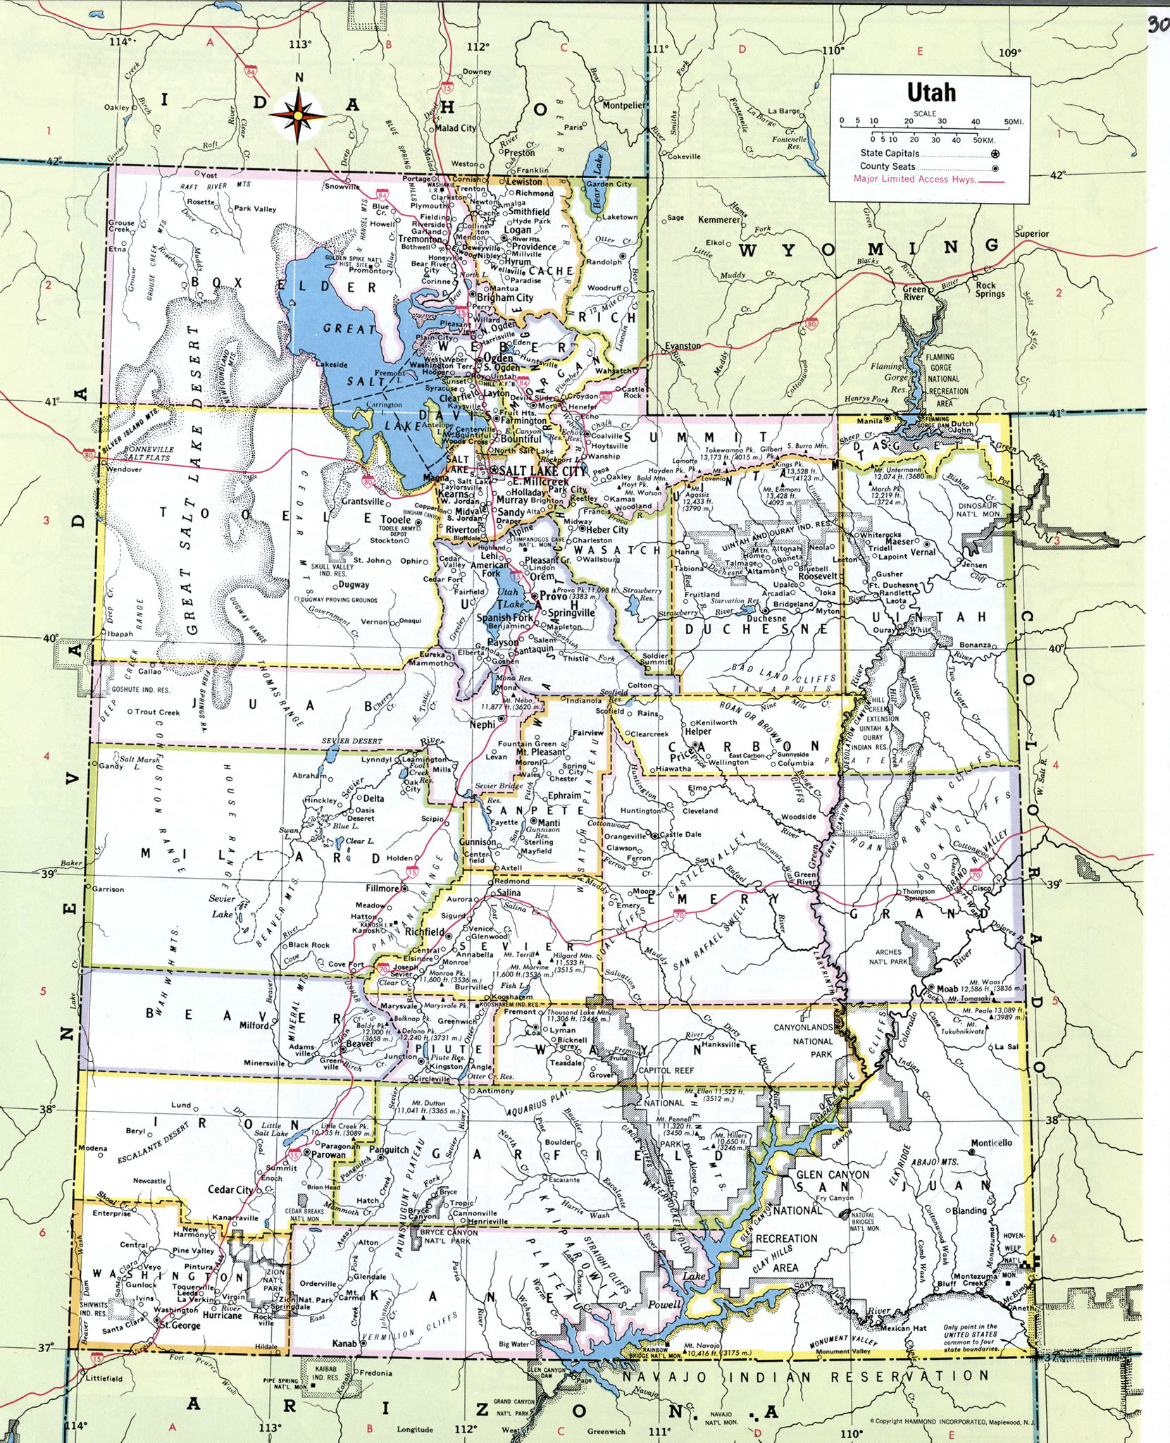

B3. Which category best fit the project based on the project’s description?
□ 1. Access
In the project description (Section B), include evidence demonstrating your willingness and ability to protect OHV access responsibly and effectively. In addition to the standard sections below, be sure to complete Section D.
□ 2. Education
In addition to the standard sections below, be sure to complete Section E.

B4. What type of OHV use(s) will benefit from the project?
□ Motorcycle □ ATV □ Side-by-Side □ 4WD □ Snowmobile

B5. Anticipated Project Start Date: _______________

Note: The project start date should be at least 4 weeks after the application deadline in order for a contract to be signed with the Utah Division of Parks and Recreation Off-Highway Vehicle Program.
Estimated Completion Date: _________________
Note: The completion date should be no later than June 30, 2022.

Outline an anticipated schedule/timeline of the proposed project's major components in the space below.

Section C: Project Budget

Complete the budget below (C1). This is a critical component of the application so, the more detailed, the better.

PLEASE NOTE: Budget allowances for contingencies will not be funded by this program.

C1. ACCESS AND EDUCATION GRANT - BUDGET
PROJECT TITLE:
ITEM DESCRIPTION  Category, Item, Quantity  (Example: Labor, Volunteer Hours, 45 @ $24.99/hour)  If funding intends to purchase specific item(s), please include pictures and/or price quotes.  PLEASE BE AS DETAILED AS POSSIBLE. | VALUE OF ITEM LISTED ($)
REQUESTED
FUNDING
1.
2.
3.
4.
5.
6.
7.
8.
TOTAL:
(Request should mirror A9 and cannot exceed $17,500.00)
Please double-check that numbers and addition is correct.
Section D: Details of Category 1 (Access) projects.

D1. How will you measure the overall effectiveness of the project description in the overall quantity and quality?

D2. Please describe your charitable organization’s history with protecting access to public lands in the state of Utah.

Section E: Details of Category 2 (Education) projects.

E1. How will you measure the education project's reach in terms of quantity and quality (e.g. number of impressions and duration or extent of interaction)?

E2. How will you measure the education project's effectiveness in terms of perceptions or behavior both before and after the implementation of the project?

Section F. Mission

F1. Please describe the charitable organization’s mission and how it pertains to access and education.

