INSTRUCTIONS FOR THE UTAH DIVISION OF PARKS AND RECREATION

OFF-HIGHWAY VEHICLE PROGRAM

FISCAL INCENTIVE GRANT

QUARTERLY APPLICATION

ELIGIBLE APPLICANTS

Applications to the Fiscal Incentive Grant (FIG) Program may be submitted by any federal agency, state agency, political subdivision of the state, or organized user group. "Organized user group" means an off-highway vehicle (OHV) organization incorporated as a nonprofit corporation in the state under Title 16, Chapter 6a (Utah Revised Nonprofit Corporation Act), for the purpose of promoting the interests of OHV recreation.

ELIGIBLE PROJECTS

The FIG Program can fund a wide range of projects as they benefit OHV recreation. Projects should fit in one or more of the following categories:

1. All FIG funds may be spent on the construction, improvement, operation, acquisition, or maintenance of publicly-owned or -administered OHV facilities (including infrastructure). This trail work may include; the development and rehabilitation of trailside and trailhead facilities, the purchase and lease of trail construction and maintenance equipment, the acquisition of property for trails/trailheads, and the assessment of trail conditions for accessibility and maintenance.

2. Up to 20% of FIG funds may be spent on access protection such as the participation in federal travel-planning processes by OHV organizations, the State of Utah, and its subsidiaries.

3. Up to 5% of FIG funds may be spent on search and rescue (SAR), such as the goods and services that SAR teams need for effective response to OHV-related incidences.

4. Up to 5% of FIG funds may be spent on tourism, such as the promotion and administration of OHV related events and/or facilities.

5. Up to 5% of FIG funds may be spent on education, such as the development and dissemination of publications as well as the operation of educational programs that promote safety, courtesy, and resource conservation related to OHV trails (including non-law enforcement trail safety and trail-use monitoring patrol programs).

6. Up to 5% of FIG funds may be spent on other uses that further OHV policy directly related under Title 41, Chapter 22, Section 1: "It is the policy of this state to promote safety and protection for persons, property, and the environment connected with the use, operation, and equipment of off-highway vehicles, to promote uniformity of laws, to adopt and pursue a safety education program, and to develop trails and other facilities for the use of these vehicles."

FUNDING CAP

For the quarterly applications, each applicant's request is limited to $12,500 or less.

MATCHING FUNDS

All projects must offer matching funds, and we encourage at least a portion of those funds to come from the project sponsor, directly. Projects that offer more match (such as 50% of the total project cost) will be more competitive. This expectation is especially the case for projects in which OHV recreation is not the only use, such as many interpretive signs, tourism facilities, and search-and-rescue operations. Leveraging support is a primary way for proposed projects to meet the FIG intent of incentivizing opportunities for responsible OHV recreation.

TRAIL-WORK GUIDELINES

As FIG applicants engage in the design, construction, and maintenance of OHV trails, they should strive to provide for the OHV operator's interests while ensuring resource conservation. Whether they are land managers or partners, applicants can work toward this goal by utilizing the book “Great Trails: Providing Quality OHV Trails and Experiences” published by the National Off-Highway Vehicle Conservation Council. (Electronic copies are available free of charge at www.nohvcc.org.) This book will provide applicants with a framework and guidelines to make informed decisions on where to locate sustainable OHV trails to increase operator satisfaction and resource conservation while reducing the burden of maintenance.

THE PROCESS

Submitted applications will be reviewed by the Utah Off-Highway Vehicle (OHV) Advisory Council on a quarterly basis. The anticipated quarterly reviews should take place during the months of January, April, August and October of each calendar year. After the Council’s review they will then make recommendations to the State Parks Board. The State Parks Board will then approve or disapprove a submitted application, and award notification is to be expected six- to eight-weeks after the quarterly deadline.

Applicants may be contacted to clarify the details and merits of their proposal. Applicants may also be contacted to arrange an on-site tour of the project for Advisory Council members.

If project managers have questions please contact Chris Haller, OHV Program Coordinator, at (801) 349-0487 or chrishaller@utah.gov .

TIMELINE

Applications must be in the Utah Division of Parks and Recreation Salt Lake Office on or before 5 PM, Wednesday April 15, 2020. Late applications will not be accepted.

Please submit FIG applications electronically to:

racheltoker@utah.gov

or by mail:

RACHEL TOKER

UTAH DIVISION OF PARKS AND RECREATION

1594 West North Temple Suite 116

PO Box 146001

Salt Lake City UT 84114-6001

APPLICATION INSTRUCTIONS

One completed and signed, the application must be mailed (U.S. Postal Service, FedEx, UPS, etc.), hand delivered, or emailed to the address above.

All items listed below under “Application Checklist” must be included in order to be considered for grant funding.

All responses must be provided in space allocated.

Text of responses should be in 11-point Arial font.

Drawings and charts on 8 ½ " X 11 " document, in either portrait or landscape orientation.

In addition to this format, if the application is submitted electronically, all documents should be converted to a single PDF file that has the applicant's digital signature.

APPLICATION CHECKLIST

□ COMPLETED AND SIGNED APPLICATION
□ MAP of the project for which funding is being requested, if applicable
□ PROOF OF RIGHT-OF-WAY, if applicable
□ APPRAISAL REPORT, if applicable
□ DETAILED PROJECT BUDGET
□ LETTER OF SUPPORT
□ FUNDING COMMITMENT LETTERS FROM OTHER FUNDING ENTITIES
□ PHOTOGRAPHS OF PROPOSED PROJECT
□ NONPROFIT organizations only: Include proof of nonprofit-corporation status and land-management agency permission.

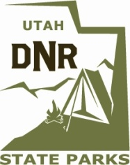
UTAH DIVISION OF PARKS AND RECREATION
OFF-HIGHWAY VEHICLE

FISCAL INCENTIVE GRANT

APRIL 2020 QUARTERLY APPLICATION

Section A: Project Overview

A1. Project Title: ____________________________________________________________

A2. Project Sponsor: _________________________________________________________

A3. Location (nearest town): ___________________________________________________

A4. County or counties: ________________________________________________________

A5. Project Manager: _________________________________________________________

A6. Address: _______________________________________________________________

A7. Telephone: ______________________ 8. E-mail: ____________________________

A9. Amount of fiscal assistance requested $_____________________(round up to nearest dollar)
(must be less than the total-project cost)

A10. Total estimated project cost $_____________________(round up to nearest dollar)

CERTIFICATION:

I certify that I am authorized to sign this application and that the information herein provided is, to the best of my knowledge, true and accurate. I further certify that the applicant has the necessary financial resources to fulfill all obligations relative to this project including the cost of operation and maintenance. I further certify that this application is submitted by an official action of the governing board of the applicant agency.

___________________________________________________________________________________
Signature of Authorized Agent Title Date

Section B: Project Description

B1. In the space below, provide a description of the project. Convey the need or problem, and how it would be satisfied or solved. Specify what is to be done. If it is a trail, does the project provide physical connections between resources, link existing community or regional trails, enhance access to OHV recreational opportunities, and/or enable residents to use OHVs? If it is a facility, specify exactly what is to be built. If it is an education campaign, specify any message/s, curriculum, method of delivery, or anticipated outcomes. Address current and projected use by providing visitor statistics, traffic counts, or similar data for the area.

You may add one more page for the project description.

B2. On the statewide map below, highlight the location of project area(s). If applicable, provide a more detailed map and GIS coordinates of the project area as well.

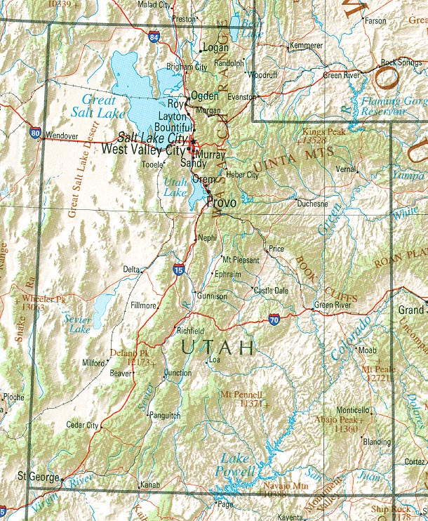

B3. Which category or categories best fit the project?

□ 1. Trail work
In addition to the standard sections below, be sure to complete Section H.
□ 2. Access protection
In the project description (Section B), include evidence demonstrating your willingness and ability to protect OHV access responsibly and effectively.
□ 3. Search and rescue
In addition to the standard sections below, be sure to complete Section G.
□ 4. Tourism
In addition to the standard sections below, be sure to complete Section F, and possibly Section H.
□ 5. Education
In addition to the standard sections below, be sure to complete Section E, and possibly Section H.
□ 6. Other use that directly benefits OHV recreation
In the project description (Section B), explain how the project would further the policy set forth in U.C.A. 41-22-1, which states "It is the policy of this state to promote safety and protection for persons, property, and the environment connected with the use, operation, and equipment of off-highway vehicles, to promote uniformity of laws, to adopt and pursue a safety education program, and to develop trails and other facilities for the use of these vehicles." Sections E - H may also apply to this category of project.

B4. What type of OHV use(s) will benefit from the project?
□ Motorcycle Singletrack □ ATV □ Side-by-Side □ 4WD
B5. Is this project a phase of a longer project? □ Yes □ No

B6. Anticipated Project Start Date: _______________ Estimated Completion Date: _______________

Outline an anticipated schedule/timeline of the proposed project's major components in the space below.

Section C: Project Budget and Funding

C1. Attach a one-page detailed project budget based on the provided "budget template," which includes:
1. project title
2. fiscal year
3. columns of
A. description (category, item, quantity)
B. requested amounts (FIG)
C. contributed amounts (match / in-kind)
D. source of contributed amounts
4. subtotals
5. total project cost

PLEASE NOTE: Budget allowances for contingencies will not be funded by this program and cannot be included as part of your match.

This is a critical component of the application. The more detailed the better. Total project costs must correlate with A9 and A10 on Page 4 of the application.

C2. Estimated annual operation and maintenance costs of the project: $

Who will be responsible for maintenance? _____________________________________

C3. Has your organization received OHV Program funding in the past (such as a motorized RTP grant, FIG grant, or any other funding amount exceeding $1,500)? □ Yes □ No

If yes, provide list of projects funded within the past 3 years and dollar amounts. For each project, specify whether complete or not complete.

C4. Nonprofit Organization □ Yes □ No

If so, provide nonprofit status (proof that your organization was incorporated as a nonprofit corporation and is currently registered), most recent by-laws, approved board meeting minutes for which funding is supported, and supporting financial documentation.

FISCAL INCENTIVE GRANT BUDGET

PROJECT TITLE: |  |  | FY____/____
ITEM DESCRIPTION  (Category, Item, Quantity)  (Example: Labor, Volunteer Hours,  45 @ $24/hour) | VALUE OF ITEM LISTED ($)
 | REQUESTED FIG FUNDING | CASH MATCH | IN KIND DONATION
1.
2.
3.
4.
5.
6.
7.
8.
9.
10.
11.
12.
13.
14.
TOTALS:
(FIG request total should match Section A9)
TOTAL PROJECT COSTS:
(Should match Section A10)
Section D: Project Partnerships

D1. Please attach no fewer than one (1) and no more than five (5) letters of support for the specific project for which funding is being requested. These may include a letter from each of the partners and any prospective clubs or organizations.

D2. In the space below, describe how you would publicly recognize contributions from the FIG program, such as placing the Division of Parks and Recreation logo on signs and uniforms, developing press releases, or event coverage:

Section E: Details of Category 5 (education) projects.

E1. How will you measure the education project's reach in terms of quantity and quality (e.g. number of impressions and duration or extent of interaction)?

E2. How will you measure the education project's effectiveness in terms of perceptions or behavior both before and after implementation of the project?

Section F: Details of Category 4 (tourism) projects.

F1. During the previous fiscal year, how much tourism took place, and what portion of that tourism was OHV recreation?

F2. Regarding the proposed project, how much total use do you anticipate, and what percent of that use do you anticipate will be from OHV recreation?

Section G: Details of Category 3 (search and rescue) projects.

G1. During the previous fiscal year, how many incidents did the SAR team respond to, and what percentage of them directly involved OHV recreation?

G2. Regarding the proposed project, how many incidences do you anticipate it will benefit, and what portion of those incidences do you anticipate will directly involve OHV recreation?

Section H: Details of Category 1 (trail work) projects.

This section should also be completed for any Category 4 (tourism) or Category 5 (education) projects that would fund facilities.
H1. Is public access guaranteed? □ Yes □ No

H2. Has environmental clearance (e.g. NEPA or RDCC) been completed? □ Yes □ No

H3. Project land is owned or administered by (Check one or more):
□ City □ County □ State □ Federal □ Private

If applicant is not the land owner/administrator, include copies of leases, easements or other agreements for use of land; or a letter from the landowner specifying that the landowner will permit the project and will execute the appropriate legal document in a timely manner.

H4. If real property is to be acquired, please write in the space below a description of the land's acquisition status and plans for a fee title purchase or other means.

H5. In the space below, describe the type and extent of facilities, as well as the kind of work to be performed. For trail work projects, list the trail types (i.e. motorized singletrack, ATV, side-by-side, 4WD) and lengths that will receive each kind of work (i.e. construction, reconstruction, relocation, other tread work, corridor clearing, and installation of signs or structures).

