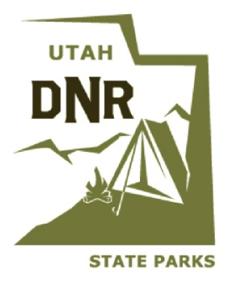

Utah Division of Parks and Recreation Americans with Disabilities Act Discrimination Complaint Form

The Utah Division of Parks and Recreation is committed to accessibility in our programs, services, events and facilities. If you believe you have been discriminated against at one of our programs, services, events or facilities on the basis of a disability, please complete this form and send it by email to Utah Division of Parks and Recreation ADA Resources Coordinator jparsonsbernstein@utah.gov. Fields marked with an asterisk (*) are required. ***If you are unable to fill out this form and would like assistance, please call the Division of Parks and Recreation at 801-538-7220 and a designated staff person will ask you the information required on the form and fill in the answers as you state them. The designated staff person will read back all of your answers to you to make sure they have taken them down correctly. If neither email or phone work for you, please contact us to help you complete the form in an accessible format suitable to your needs.

Please provide your:

First Name * Middle Name Last Name * Suffix
Address * City * State * ZIP *
Telephone * Email *

Please provide the following information about the Utah Division of Parks and Recreation Facility at which the incident you are reporting took place:

Institution Name *

Address * City * State * ZIP *

Telephone * Email *
Please provide the date and time the incident you are reporting occurred:
Date Time
Please list names of person(s) you believe have been discriminated against because of a disability (if other than the person listed above):

Please provide the following information as allowed by the U.S. Department of Justice:
Primary type of disability *

Issue *

Please describe the incident about which you are reporting: *

Has the complaint been filed with the Department of Justice or any other Federal, State, or local civil rights agency or court? *
Yes No

At which agency or court has the complaint been filed?

When was the complaint filed? Date:

Thank you for filling out this form. The Utah Division of Parks and Recreation ADA Resources Coordinator will send you an acknowledgement of the receipt of this completed form when it is received. How would you like this acknowledgement sent?

Email ____ Phone Call ____ Relay Utah ___ Other (please specify) _______________

If form filled out by Division Employee: Name of employee: ________________________________________ Date: ___________________

