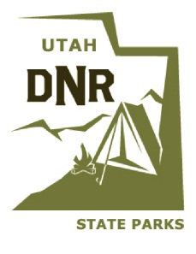
Utah State Parks
Department of Natural Resource
Goblin Valley State Park
PO Box 637
Green River, UT 84525
(435)275-4584

_______________________________________________________________________________
Backcountry Permit
Goblin Valley State Park
Date:

Name:

Phone number:

Number of people in group:

Vehicle license plate and state:

Emergency contact phone:

Need-to-Know Info
- ASSOCIATED RISK. Canyoneering is an inherently risky activity; you assume all risks related to this activity. Use proper judgment and keep a close watch on everyone in your group. Check each person’s equipment before they begin the rappel—are they wearing everything properly?
- BOLTS. Bolts are not allowed in the park. Please respect this rule and help us conserve the natural beauty of Goblin Valley. There is a horn (rock) at the rappel point for tying anchors.
- GEAR. Be sure that each person in your group has their own harness, carabiner, and descender. Sharing gear causes huge delays and longer waits at the rappel point. If this continues to be an issue, daily permits for this rappel will become more strictly limited.
- HELMETS. We advise all people rappelling to wear a helmet. If even a single rock breaks loose, a helmet can save your life.
- PRUSIKS. If you do not have prior experience using a Prusik knot for a backup, do not use a Prusik knot on this rappel. Most rescue operations in Goblin’s Lair are related to Prusik knot mishaps.
- COMMERCIAL PERMITS. This is not a commercial permit. If you are guiding paying clients, you must get a special use permit.

Permit #:

Date:

Permit #:

